**CI FOR CSP COMPONENTS**

# **Steps for CSP Job configuration (EAR)**

**Step 1**: Click on Configure and fill the require fields.

* **Project name**: Give the component name.
* **Description:** Give the following description:

<span style="color: #ff9933; font-size: 10pt; font-family:verdana; font-weight: bold; font-style: italic; ">This job will do get latest,Build,package,Unit Testing,Sonar Analysis,Quality gate based on code metrics and publish the artifacts into IBM udeploy every 30 mins in case of any code changes in <u>CommercialAirtightProxy</u> component(EAR) of CSP application</span>

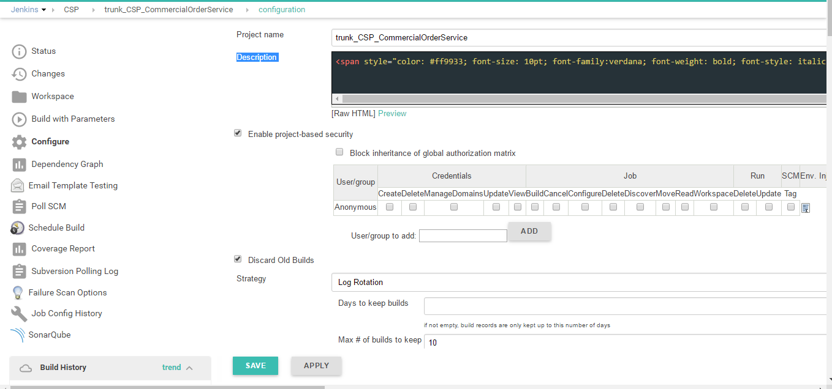

* Enable the project based security and Discard Old Builds, keep the Max # of builds to 10.

**Step 2:**

* Parameterize the build and Add Parameter (String parameter)
* Name: Give some name to the parameter.
* Default Value: NA.
* Description: Give description for the parameter.
* Keep the JDK as the JAVA6 CSP linux agent.

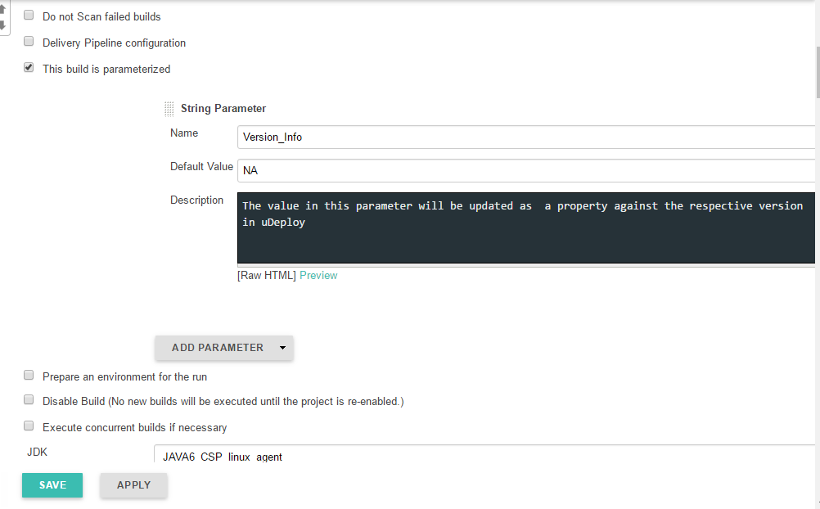

**Step 3:**

* Restrict the Project on the CSP Agent.
* **SCM**: Select the Subversion and give the repository URL for the required component.
* **Credentials**: Authenticated User’s ID and password should be provided over here.

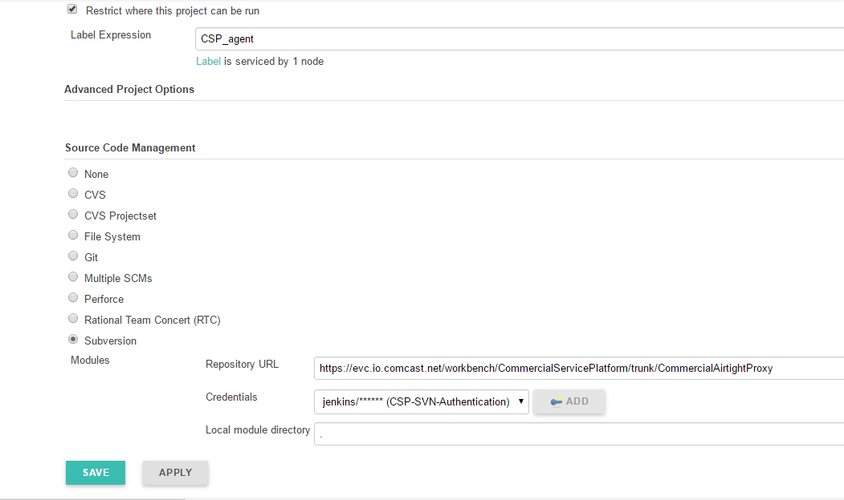

**Step 4:**

* Poll SCM in every 30 minutes, it will poll the SCM at every 30 minutes and build the job itself so that every new change in SCM will be reflected in the job build.

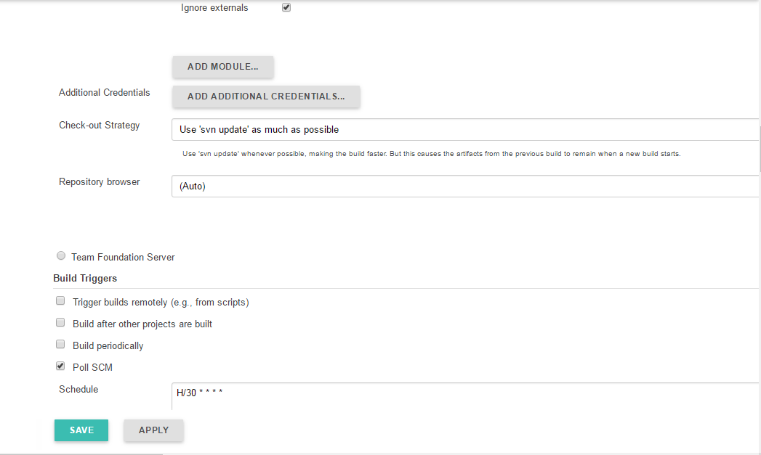

**Step 5:**

* Check the Delete the workspace before build start check box so that the old workspace does not conflict with the new one and the workspace contain the fresh folders.
* Check the Add timestamp to the Console Output (wrap the rest of the pipeline script).

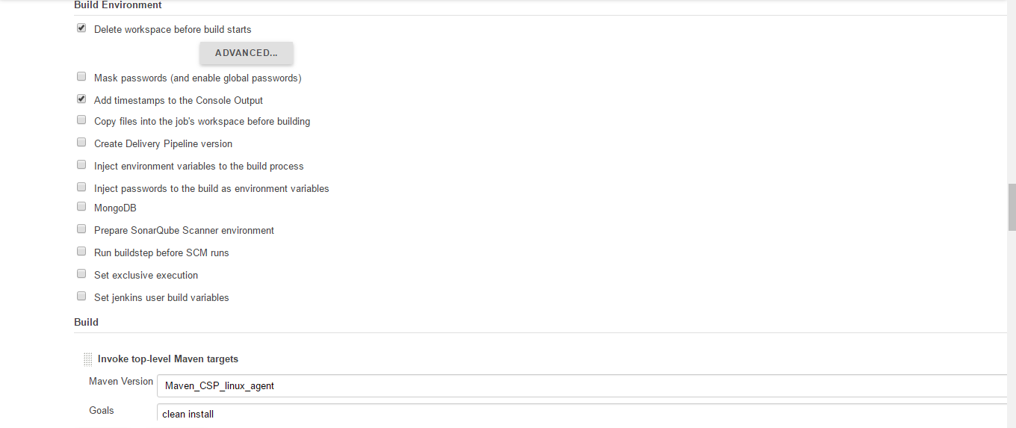

* Add a Build step as **Invoke top-level Maven target.**
* **Maven Version**: Select as Maven_CSP_linux_agent.
* **Goal**: If there are **test cases** in a particular component then provide the **Goal** as clean install but if there are **no test cases** for a particular component then the Goal should have the skip test cases then in the **Goal** provide clean install -Dmaven.test.skip=true.

**Step 6:**

* Add next build step as **Execute Groovy Script.**
* **Groovy Version**: Select the CSP_ AGENT _GROOVY.
* **Groovy script file**: /app/home/jenkins/retrieve_pom.groovy.
* Add next build step as **Inject environment variables.**
* **Properties File Path**: Provide as envInject.properties.

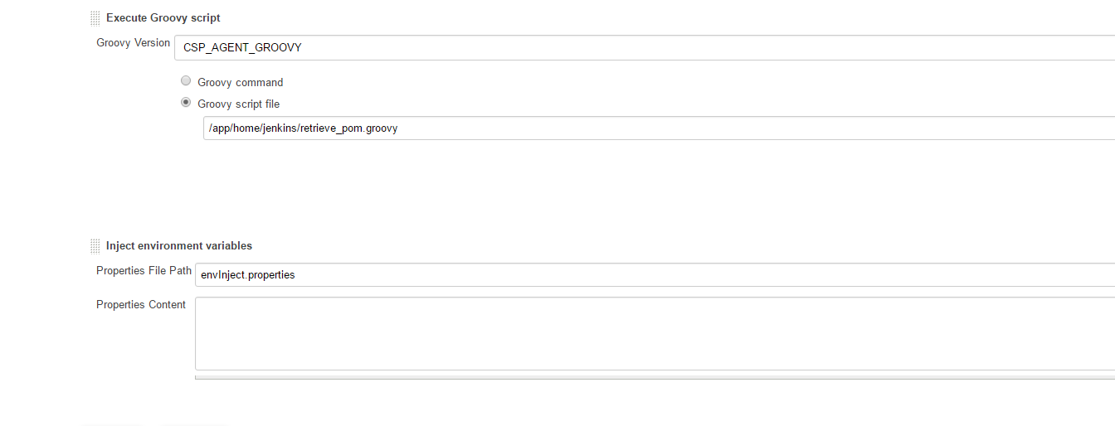

**Step 7:**

* Add next Build Step as **Execute SonarQube Scanner**.
* **JDK**: Provide as JAVA8_CSP_linux_agent.
* **SonarQube** **Scanner**: SonarRunner 2.6.1 Agent.
* **Analysis properties**: Provide the appropriate Sonar Properties which will contain the projectKey,projectName,projectVersion, sonar java binaries(if the project does not have any test cases) but if the project has test cases then the junit report path and cobetura report path should also be mentioned in the analyses properties along with the projectKey,projectName,projectVersion, sonar java binaries.

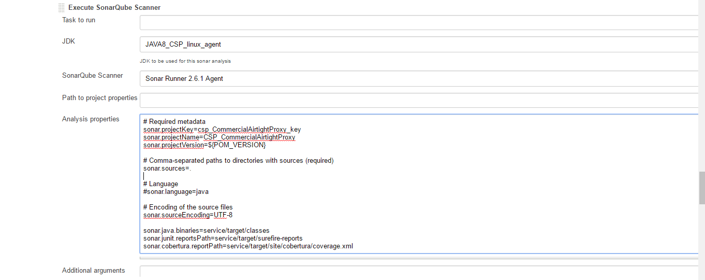

**Analysis properties**

# Required metadata

sonar.projectKey=csp_CommercialAirtightProxy_key

sonar.projectName=CSP_CommercialAirtightProxy

sonar.projectVersion=${POM_VERSION}

# Comma-separated paths to directories with sources (required)

sonar.sources=.

# Language

#sonar.language=java

# Encoding of the source files

sonar.sourceEncoding=UTF-8

sonar.java.binaries=service/target/classes

sonar.junit.reportsPath=service/target/surefire-reports

sonar.cobertura.reportPath=service/target/site/cobertura/coverage.xml

**Step 8:**

* Add the next build Step as **Execute Shell** and provide the appropriate shell script over it.

mkdir SVN_EAR

cp ear/target/*.ear ./SVN_EAR/

java -jar /app/home/jenkins/FileCheckin-0.1.jar https://evc.io.comcast.net/workbench/CommercialServicePlatform/DeploymentArtifacts/CloudSet_CICD/CommercialAirtightProxy/${POM_VERSION}.${BUILD_ID}/EAR/ ./SVN_EAR

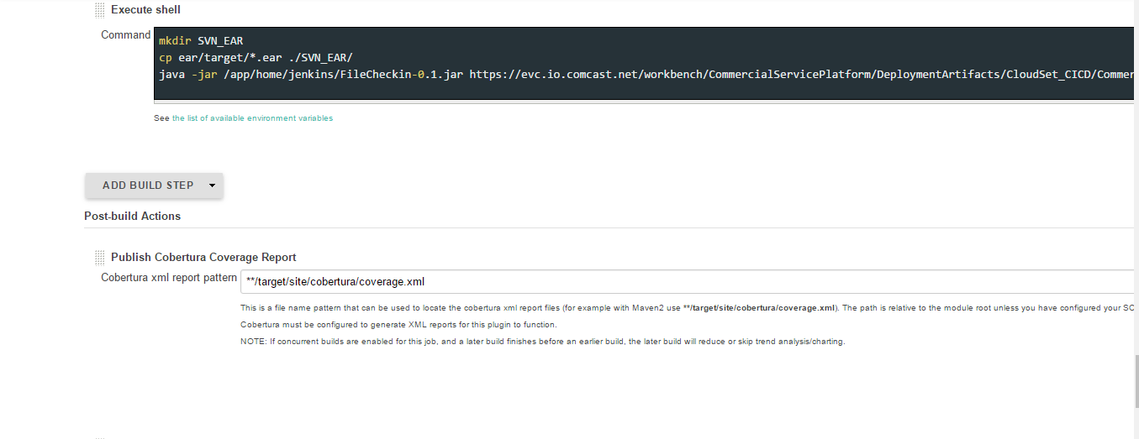

* In case the component has No test Cases add a post build **step** as **Publish Cobetura Coverage Report (if there are no test cases skip this step).**
* **Cobetura xml report pattern**: **/target/site/cobertura/coverage.xml (it will take the path of the coverage report from the workspace).

**Step 9:**

* In case the component has No test Cases add next **post build** **step** as **Publish Junit test result report (if there are no test cases skip this step).**
* **Test report XMLs:** **/target/surefire-reports/*.xml (it will take the path of the test report from the workspace).

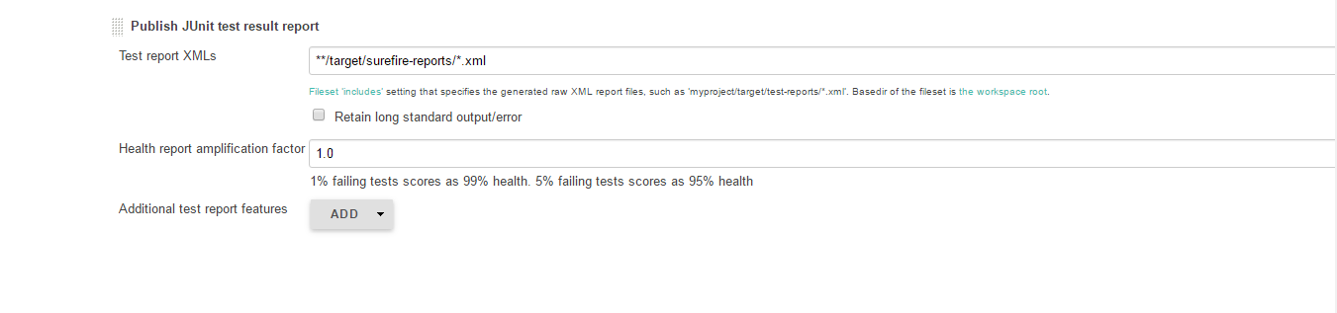

**Step 10:**

* Add the next **Post Build Step** as **Editable Email Notification**.
* **Post Recipient List**: Specify a single recipient list for each email that is sent (${CSP_MAIL_RECIPIENT}).
* **Project Reply-To-List**: ${CSP_MAIL_REPLYTO}
* **Content Type**: Select the content type as Both HTML and Plain Text
* **Default Subject**: This will define the subject of the mail sent to the recipient${CSP_MAIL_SUBJECT} ${JOB_NAME}
* **Default Content**: Content of the e-mail ${JELLY_SCRIPT,template="cspemailtemplate"}
* **Attach Build Log**: Select it as Do Not Attach Build Log.

